**Attack of the Memes Progress**

**Muhammad**

Level Designer

**Ashton**

Writer, Character Artist

**Mamadou**

Composer

**Thien**

Character Artist

**Martin**

Programmer

**Day 1 - 2:**

**Objective**: Player can fight memes to beat game or escape

**Concepts for Setting:**

**Basement (Writer choose this)**

Restaurant

**Memes (each of us picked):**

Muhammad: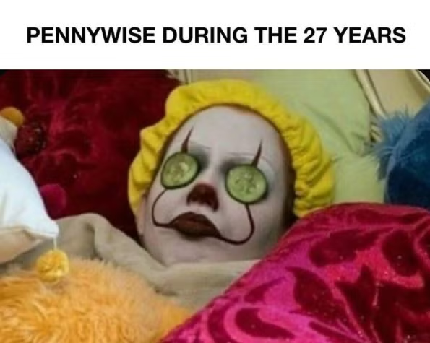 Ashton: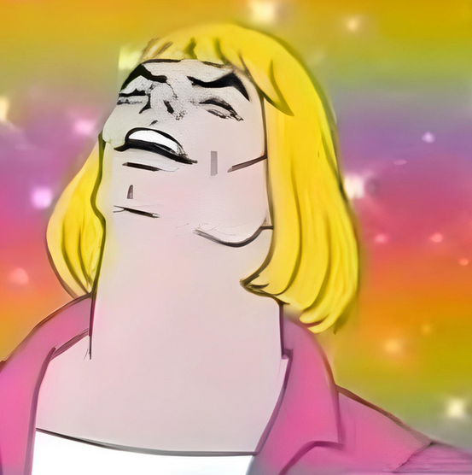 Mamadou: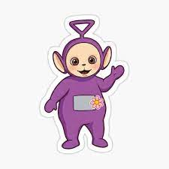

Thien: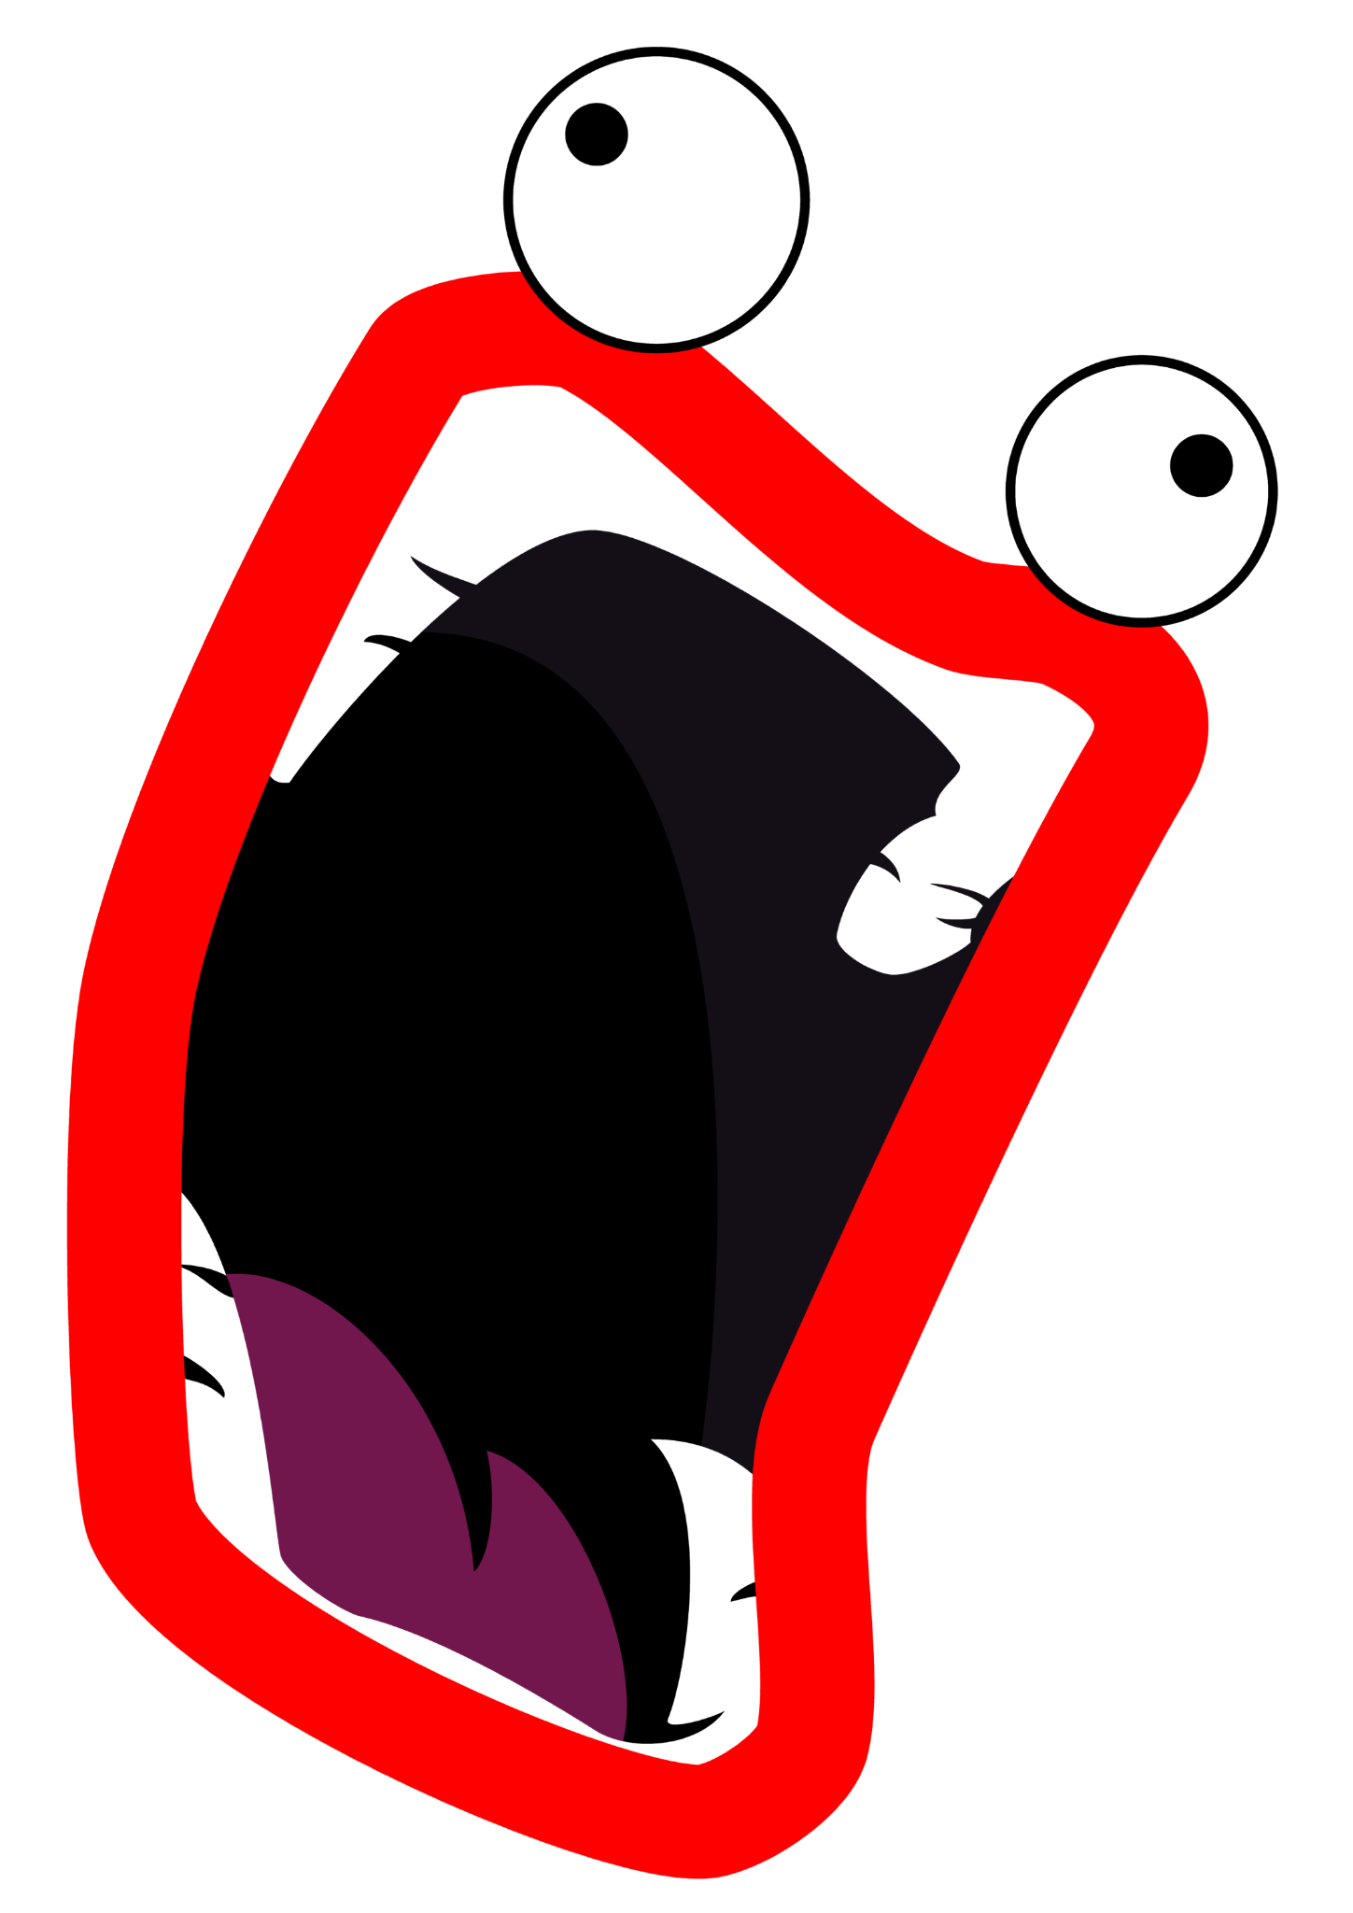 M

**Story(written by Ashton):** for some reason you are in a basement for reasons you can't remember but you have no time to try to remember things with 5 devilish fools on the rise spa day pennywise , , tinky winky , i'm firin mah lazer guy , Philip J. Fry , he man and he doesn't know what's going on .

artin: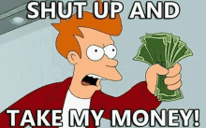

**Scrapped Memes (due to copyright):**

Thien: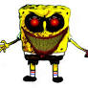 Martin: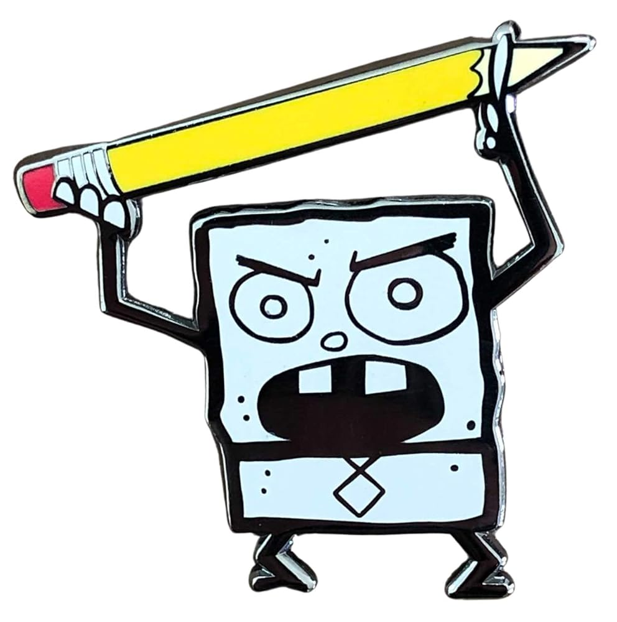

**Group Websites (V1):**

Group Name and Game Title made by Ashton.

Text color and font made by Muhammd.

Document for the website made by Mamadou.

**(Scrapped) Slendybob Redesign - Thien Le:**

I took the scrapped mascot of my theater class that I designed.

I choose this as I don’t want the game to get copyrighted by Nickoloden and that my theater class chooses an inappropriate logo over the spongebob logo.

References: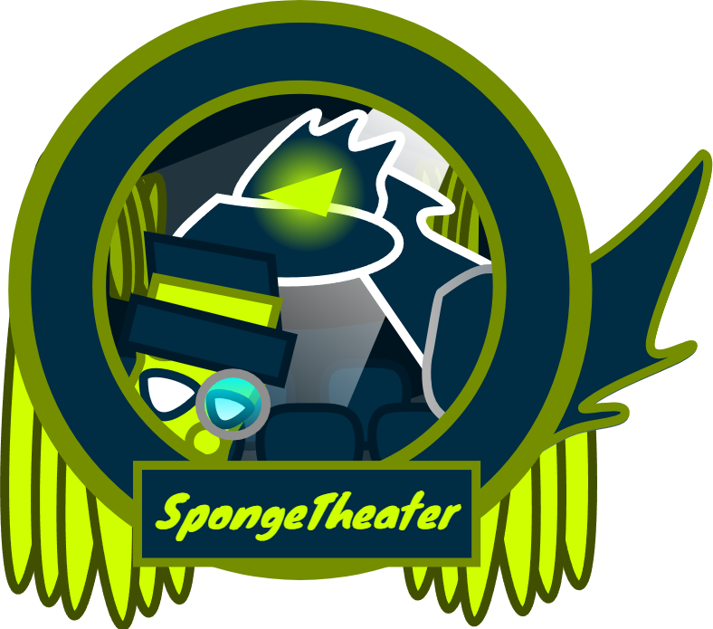

Concept One: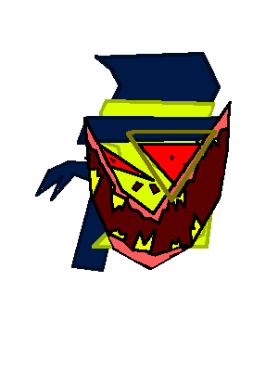

**Day 4:**

**Shoop da Whoop - Thien Le:**

References: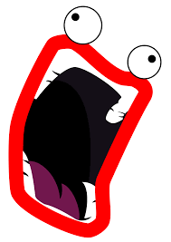

Drawing: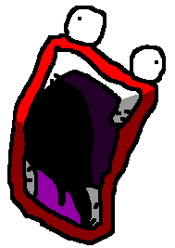

**Heman - Ashton:**

Reference: 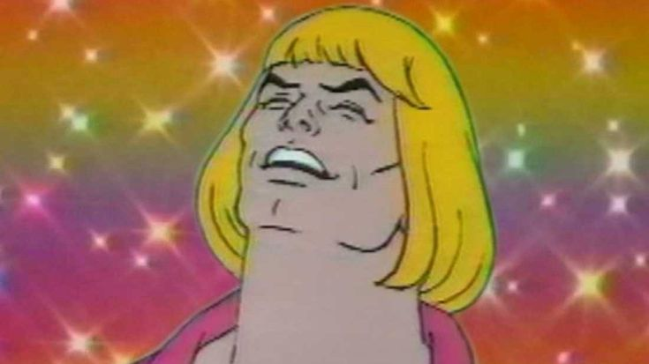

Drawing: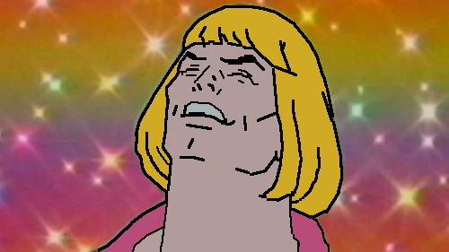

**Philip J Fry - Thien Le:**

Reference (Front View):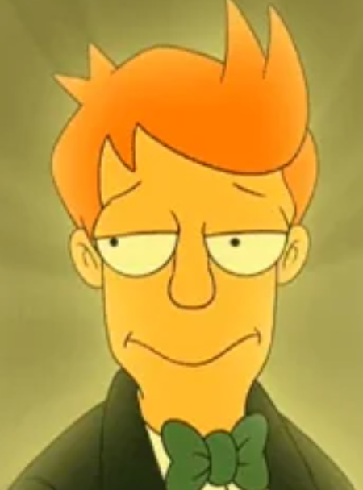

Reference (Body):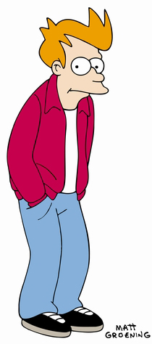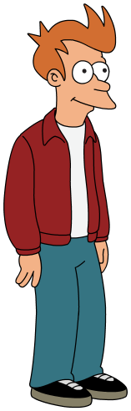

Drawing: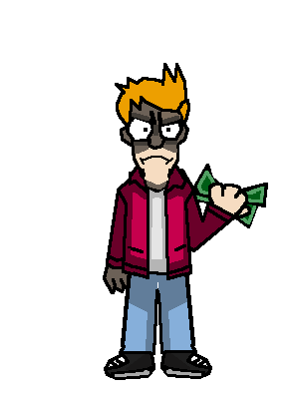

**Spa Pennywise - Thien Le:**

References: 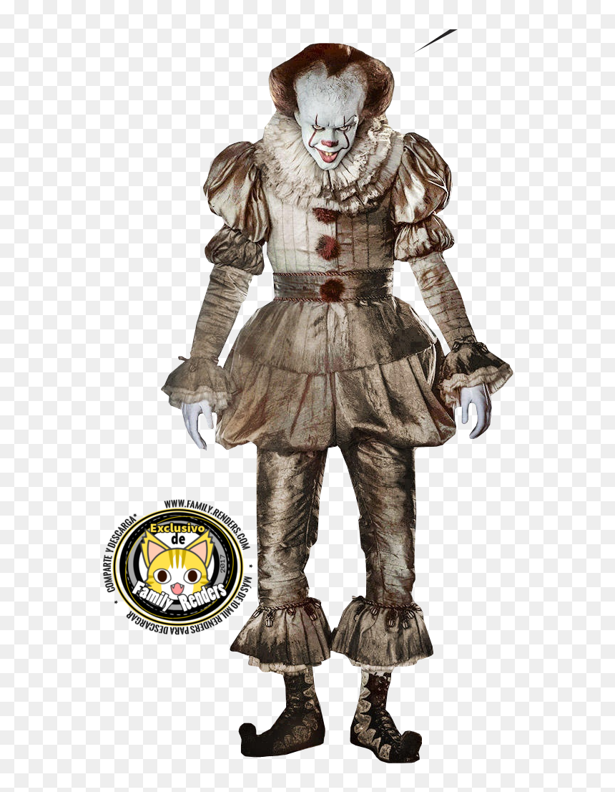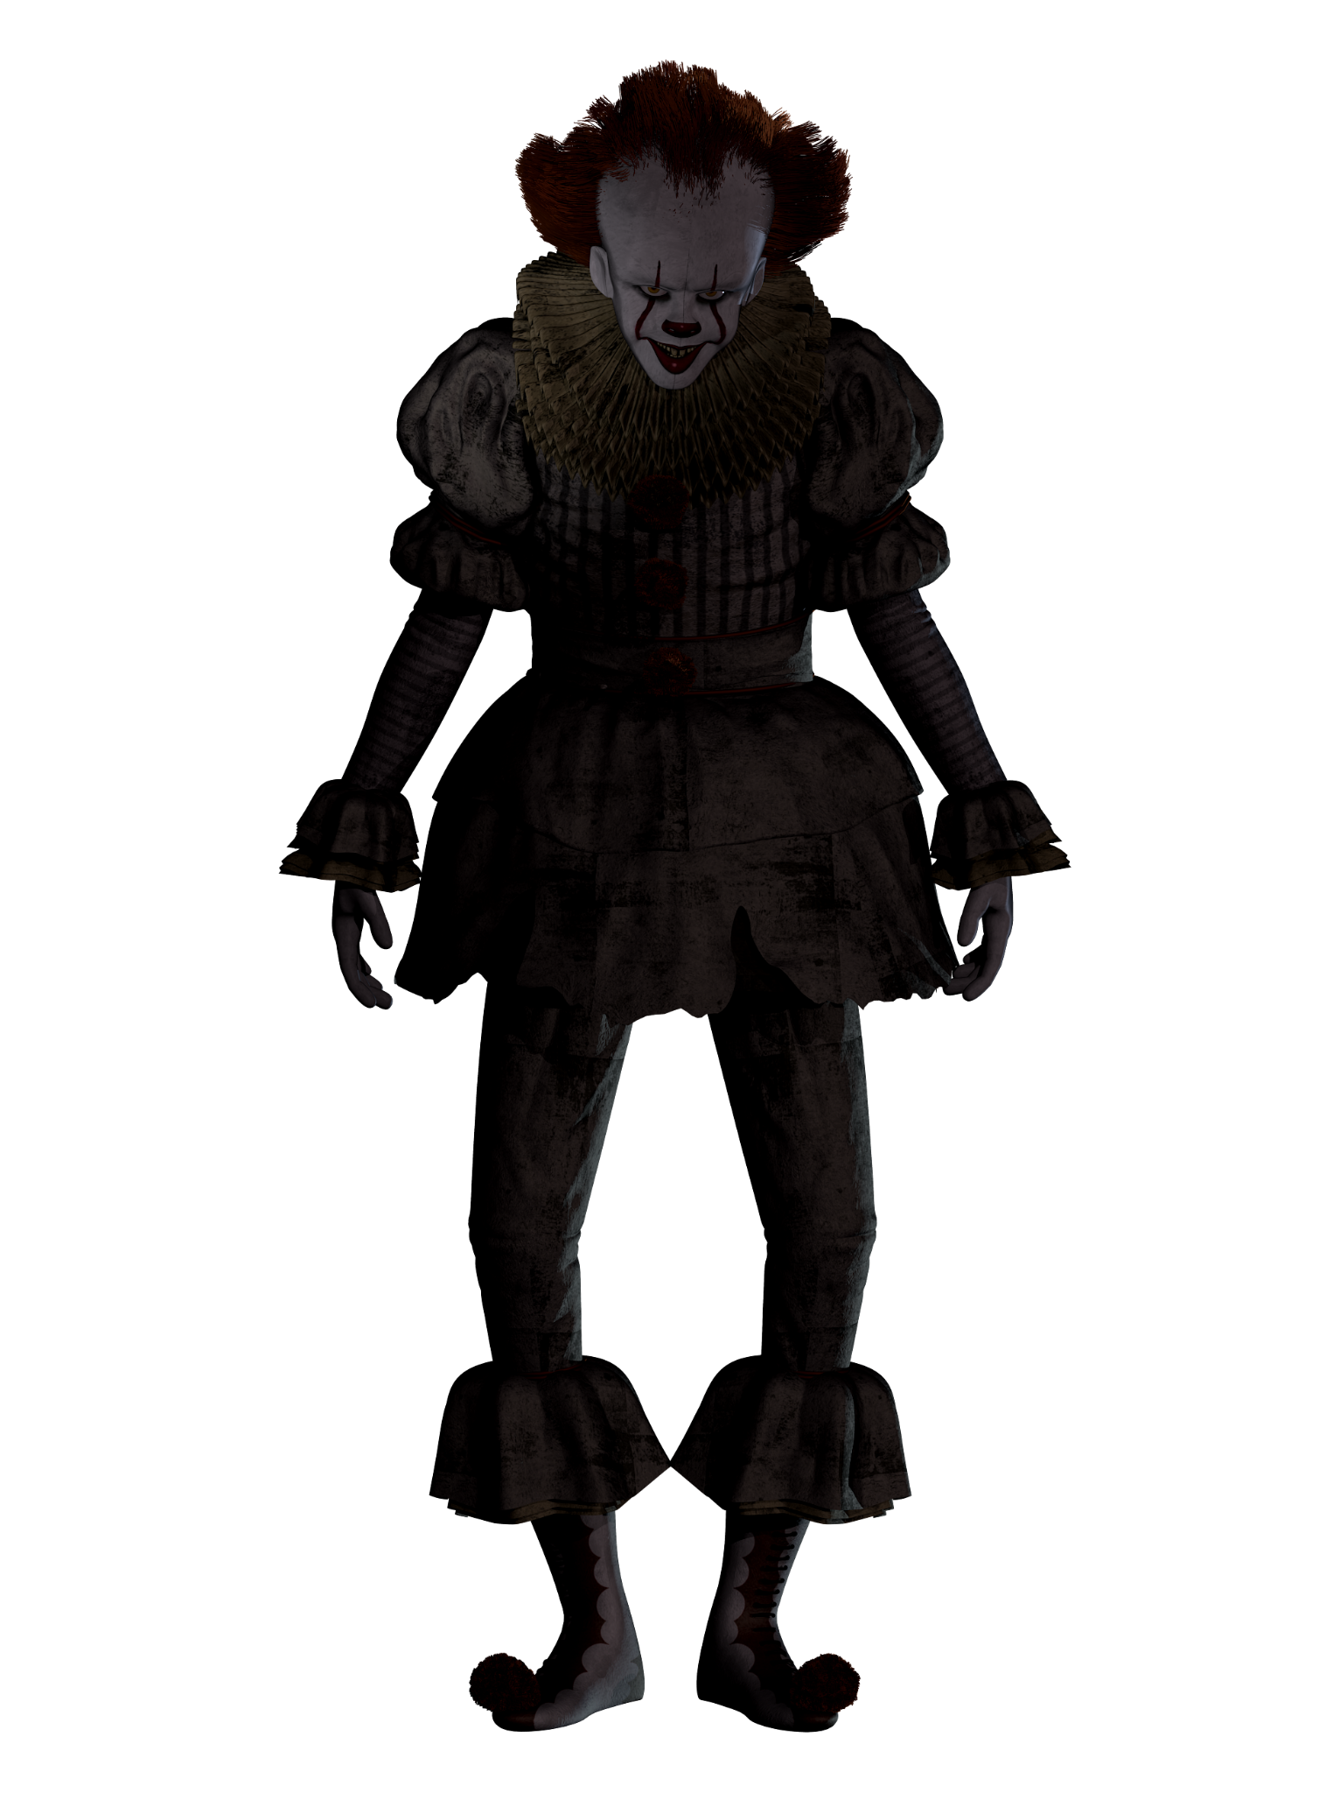

Drawing: 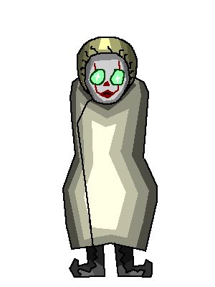

**Tinky-Winky - Ashton**

References: 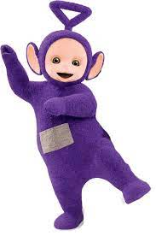

Drawing: 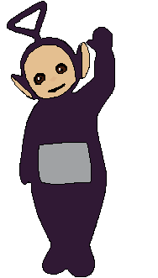

**Audio - Mamadou:**

[Soundtract 1](https://drive.google.com/file/d/1gGiWnAO0U3QezwlhlxwVpvs0kVU0nV3t/view?usp=drive_link)

[Soundtrack 2](https://drive.google.com/file/d/1I0ADB7aA5tM1iLYXsxz7bDGnO5N7RJRo/view?usp=drive_link)